Early-Warning Alarm Before the Makino Breaks Down: Random Forest Detects Failure Signals from 2,500 Sensor Logs (and Coolant Pressure Becomes the Prime Suspect)

Amelia Vega*¹

¹Departemen Pendidikan Matematika, Universitas Negeri Malang,
Jl. Cakrawala No.5, Sumbersari, Kec. Lowokwaru, Kota Malang, Jawa Timur, Indonesia 65145

Abstrak

Predictive maintenance (PdM) memanfaatkan data sensor untuk mengantisipasi kegagalan lebih dini sehingga perawatan dapat dilakukan secara proaktif. Studi ini mengembangkan pipeline PdM end-to-end yang menghasilkan skor risiko kegagalan dari data tabular multisensor serta menjelaskan skor tersebut secara actionable (dapat ditindaklanjuti). Menggunakan dataset publik Kaggle tentang machine downtime (~2.500 rekaman), target didefinisikan sebagai kegagalan pada langkah berikutnya (next-step failure, y_next) dengan menggeser label satu langkah ke depan di dalam setiap Machine_ID. Pemisahan data berbasis waktu diterapkan untuk meniru kondisi implementasi nyata dan mencegah data leakage. Tiga model dievaluasi, Regresi Logistik, HistGradientBoosting, dan Random Forest, dengan keluaran probabilitas sebagai skor risiko serta metrik yang berfokus pada pemeringkatan risiko (PR-AUC) ditambah presisi/recall. Random Forest mencapai performa terbaik (PR-AUC 0,462; presisi 0,528; recall 0,571 pada ambang 0,5). Threshold sweeping digunakan untuk menyeimbangkan beban inspeksi versus kegagalan yang terlewat, dengan menerjemahkan ambang menjadi volume peringatan harian dan prioritas mesin. Interpretabilitas melalui permutation importance menyoroti klaster pendorong utama (torsi–pemotongan–getaran) serta subsistem pendukung (coolant, hidrolik, kelistrikan), yang dipetakan ke dalam daftar periksa inspeksi untuk mengubah peringatan menjadi alasan yang jelas dan tindakan rekomendasi..

Kata kunci: predictive maintenance; machine downtime; Random Forest; penilaian risiko; penyetelan ambang; beban peringatan; explainable AI (XAI); permutation importance; data sensor industri; Industri 4.0.
Abstract

Predictive maintenance (PdM) uses sensor data to anticipate failures early so maintenance can be done proactively. This study develops an end-to-end PdM pipeline that produces a failure risk score from multi-sensor tabular data and explains the score in an actionable way. Using a public Kaggle machine downtime dataset (~2,500 records), the target is defined as next-step failure (y_next) by shifting labels one step ahead within each Machine_ID. A time-based split is applied to mimic real deployment and prevent data leakage. Three models are evaluated, Logistic Regression, HistGradientBoosting, and Random Forest, using probability outputs as risk scores and metrics focused on risk ranking (PR-AUC) plus precision/recall. Random Forest achieves the best performance (PR-AUC 0.462; precision 0.528; recall 0.571 at threshold 0.5). Threshold sweeping is used to balance inspection workload versus missed failures, translating thresholds into daily alert volumes and machine priorities. Interpretability via permutation importance highlights key driver clusters (torque–cutting–vibration) and supporting subsystems (coolant, hydraulics, electrical), which are mapped into an inspection checklist to turn alerts into clear reasons and recommended actions.

Keywords: predictive maintenance; machine downtime; Random Forest; risk scoring; threshold tuning; alert workload; explainable AI (XAI); permutation importance; industrial sensor data; Industry 4.0.

1. Introduction
Predictive maintenance (PdM) has become a major Industry 4.0 use case because it leverages sensor/IoT data to detect potential failures early, enabling more planned and proactive maintenance interventions (Ayvaz & Alpay, 2021; Benhanifia et al., 2025; Tsallis et al., 2025). However, recent literature reviews indicate that truly “end-to-end” PdM implementations are still often hindered by pipeline complexity (data acquisition–preprocessing–modeling–deployment), data heterogeneity, and a gap between model performance and the practical needs on the production floor (Benhanifia et al., 2025; Tsallis et al., 2025). On the modeling side, a wide range of machine learning to deep learning approaches continues to grow, but choosing the right architecture strongly depends on the data characteristics (e.g., multi-sensor tabular data vs. time-series) and the prediction objective (e.g., failure classification, remaining useful life/RUL, or anomaly detection) (Li et al., 2024; Serradilla et al., 2022). A recurring challenge in PdM is the rarity of failure events, which creates severe class imbalance, making imbalance handling strategies and evaluation metric selection critical so a model does not appear “good” overall while still failing to detect the minority failure class (Mahale et al., 2025; McDermott et al., 2024; Richardson et al., 2024).

*Corresponding Author.
E-mail: amelia.vega.2203118@students.um.ac.id
Beyond accuracy, industrial adoption is strongly shaped by user trust, since technicians need to understand why the model assigns a high risk and which sensor features contribute most to the decision (Dereci & Tuzkaya, 2024; Steurtewagen & Van den Poel, 2021). For this reason, recent research increasingly emphasizes explainable AI (XAI) and even human-in-the-loop XAI, so model outputs better fit maintenance workflows, such as prioritization, corrective actions, and decision justification, and become easier to act on (Amaliah et al., 2025; Shadi et al., 2025). For multi-sensor tabular data, ensemble models like Random Forest are often used as a strong baseline because they are relatively robust and typically easier to interpret than many black-box approaches, and have shown good performance in applied and comparative studies (Levin, 2024; Wu et al., 2024; Yang & Wang, 2025). Building on this foundation, this research focuses on developing an end-to-end PdM pipeline that produces a failure risk score from multi-sensor operating parameters and provides feature-level explanations behind the risk, making preventive maintenance recommendations more transparent, auditable, and operational (Cummins et al., 2024; Pashami et al., 2023).

2. Research Methodology
This study uses a public machine downtime dataset from Kaggle (~2,500 records) containing machine/assembly-line IDs, timestamps, and multiple sensor/operational variables. Downtime status is binarized into is_failure (1 = failure, 0 = normal), and the main target is defined as next-step failure (y_next) by shifting the label one step forward within each Machine_ID, so each record predicts the probability of failure in the next record as a risk score (Ayvaz & Alpay, 2021). Data preprocessing includes timestamp parsing and chronological sorting per machine, missing-value imputation (median for numeric features; mode for categorical), and handling extreme values to improve robustness on industrial sensor data. To capture degradation dynamics, time-aware features are engineered for key sensors, including lags (t−1, t−2), deltas (changes relative to lag), and rolling statistics (e.g., windowed mean/std). Potential leakage features and any columns that could reveal future information are removed. Model evaluation applies a time-based split (train on earlier periods, test on later periods) to better reflect real-world deployment conditions (Benhanifia et al., 2025).
The models compared are Logistic Regression as a baseline, Random Forest as the main tree-ensemble approach, and HistGradientBoosting as a boosting benchmark, with predict_proba outputs used as the risk score. Performance is evaluated using Precision/Recall/F1, as well as ROC-AUC and PR-AUC, to keep evaluation meaningful under class imbalance and to support model selection based on operational goals (e.g., minimizing missed failures). (McDermott et al., 2024). To make the risk score actionable in practice, a threshold sweep is performed to choose an alert threshold that balances recall against the false-alarm workload, aligned with inspection capacity. Interpretability is provided through global permutation importance and case-level explanations (e.g., which sensor/features drive high-risk predictions), so maintenance teams can link alerts to concrete technical indicators and follow-up actions (Steurtewagen & Van den Poel, 2021).

3. Results and Discussion
RQ1: Model performance for next-step failure prediction. This study formulates predictive maintenance as a next-step failure problem (y_next): each record is used to predict whether the next record for the same machine will be a failure. To reflect the task difficulty and ensure the evaluation aligns with real deployment conditions, the label distribution in df_model (2497 × 24) is relatively balanced, with y_next = 1 appearing in 1,263 records and y_next = 0 in 1,234 records.

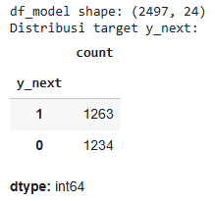

Figure 1. Dataset Shape and y_next Class Distribution

Next, a time-based split is applied to prevent data leakage, using a cut date of 2022-05-02. The training set contains 2,385 rows spanning 2021-12-17 to 2022-05-01, while the test set contains 109 rows spanning 2022-05-02 to 2022-06-19. This ensures the measured performance truly reflects the model’s ability to predict future periods, consistent with temporal validation best practices and prior warnings about the risk of future-information leakage in predictive modeling (Deng, 2023; Kapoor & Narayanan, 2023).

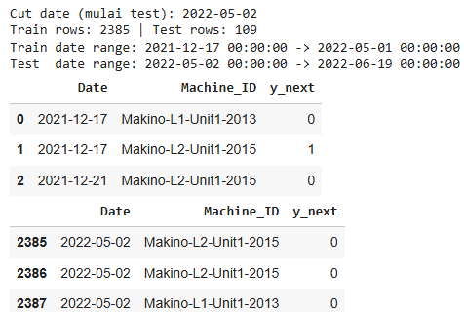

Figure 2. Time-Based Train/Test Split Summary (Cut Date and Date Ranges)

To address RQ1, this study compares Logistic Regression (baseline), HistGradientBoosting, and Random Forest using metrics that are appropriate for an early-warning system based on risk ranking—most notably PR-AUC (Average Precision)—alongside precision, recall, F1, and the confusion matrix at the default 0.5 threshold. This emphasis on the PR curve aligns with modern classification evaluation discussions that highlight how AUROC and AUPRC/PR-AUC can lead to different interpretations under various conditions (e.g., class imbalance and a focus on the positive class) (McDermott et al., 2024; Richardson et al., 2024).

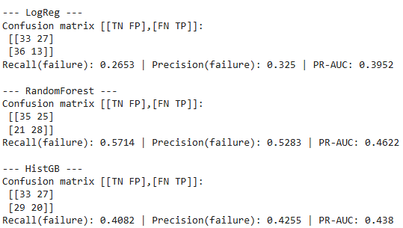

Figure 3. Model Comparison: Confusion Matrices and Performance Metrics (Precision, Recall, PR-AUC)

The results show that Logistic Regression achieves a PR-AUC of 0.395 but with low failure recall (0.265). HistGradientBoosting improves performance (PR-AUC 0.438; recall 0.408), while Random Forest performs best (PR-AUC 0.462; failure precision 0.528; failure recall 0.571) and yields the most favorable confusion matrix at the 0.5 threshold. To assess ranking quality in a threshold-independent way, the Precision–Recall curve also shows Random Forest generally dominating the others and achieving the highest Average Precision (AP).

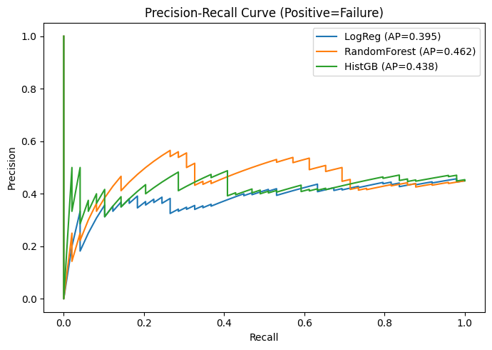

Figure 4. Precision–Recall Curves for Next-Step Failure Prediction (LogReg vs Random Forest vs HistGB)

From an interpretability standpoint, Random Forest’s advantage is expected for multi-sensor tabular data because it can capture non-linear patterns and feature interactions that are often missed by linear baselines. This aligns with recent PdM literature, where tree-ensemble models (Random Forest/boosting) are frequently reported as highly competitive for sensor-based failure prediction (Ayvaz & Alpay, 2021; Wu et al., 2024; Yadav et al., 2024) and widely discussed in modern PdM surveys (Li et al., 2024; Serradilla et al., 2022). However, the still-moderate PR-AUC suggests the predictive signal is not very strong, meaning the system’s practical value will depend heavily on threshold policy and how the risk score is operationalized (e.g., score-based inspection prioritization and scheduling), rather than chasing a single “accuracy” number.

RQ2: Threshold policy and operational workload (alarms). RQ2 treats the model output as a risk score that only becomes an alarm when it exceeds a chosen threshold (T). Therefore, threshold selection is essentially a policy decision that sets the system’s operating point, how many alerts are acceptable versus how many failures can be missed. Conducting a threshold sweep on the best model (Random Forest) is an appropriate first step because it shows how precision, recall, and F1 change across different T values and confirms that the default 0.5 threshold is not necessarily optimal. Prior work in predictive monitoring also notes that thresholds often need to be tuned to meet specific targets (e.g., an acceptable false-alarm rate), since “0.5” is largely a convention and may lead to unacceptable operational performance (Huberts et al., 2022; von Stackelberg et al., 2024). The observed trade-off matches this principle: at low thresholds (≈0.05–0.35), recall can reach 1.00 but precision stays around 0.45 (many alerts, minimal missed failures). At higher thresholds (e.g., 0.50), precision increases (0.528) but recall drops (0.571), reducing inspection workload but increasing the risk of missed failures.

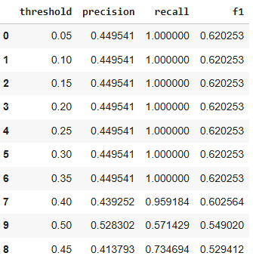

Figure 5.Threshold Sweep Results: Precision, Recall, and F1 Across Decision Thresholds

To make the RQ2 interpretation truly operational, the threshold should be translated into maintenance workload, specifically, how many alert records are generated and how many unique machines must be prioritized per day. This focus is important because alarm-management studies show that excessive alarms (alarm flooding) can reduce situational awareness, increase operator burden, and ultimately lead to alarms being ignored. Therefore, controlling false alarms and alarm volume is a core requirement in early-warning system design (Manca & Fay, 2024; Mustafa et al., 2023). The finding that workload is highly sensitive to changes in T is also statistically reasonable: the test-set risk scores are clustered around the mid-range (mean ≈ 0.499, std ≈ 0.054, range 0.364–0.652), so even small threshold shifts can meaningfully change the number of alerts

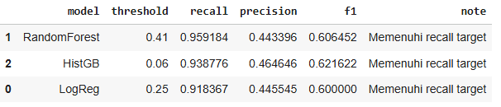

Figure 6. Models Meeting the Recall Target: Selected Thresholds and Performance Summary

Accordingly, the recommended workload metrics to report are: (1) the number of alert records, (2) the average number of alerted machines per day, and (3) the 90th percentile (p90) of alerted machines per day to capture peak-load days. This approach aligns with prior work that emphasizes explicitly balancing false alarms and missed alarms through clear threshold or signaling rules (Luo et al., 2023). An example at T = 0.5 illustrates the policy implications: the system generates 53 alerts (48.62% of the test records) with TP = 28, FP = 25, and FN = 21, meaning nearly half of the records would trigger inspection, while 21 failures would still be missed under this threshold.

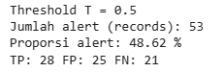

Figure 7. Alert Volume and Outcomes at Threshold T = 0.5 (TP, FP, FN Rates)

Ultimately, threshold selection can be framed as meeting either a safety/risk target (e.g., a minimum recall) or a capacity constraint (e.g., the maximum number of machines that can be handled per day). For example, T ≈ 0.41 keeps recall at around 0.959 with precision around 0.443, making it a safer choice to minimize missed failures. In contrast, T = 0.5 may be preferable when inspection capacity is limited, since precision is higher, but it comes with lower recall. This framing is consistent with prior work that (i) encourages threshold tuning to hit specific alarm targets (Huberts et al., 2022; von Stackelberg et al., 2024) and (ii) highlights the importance of post-processing risk scores into controlled alerts (e.g., alert filtering) so operational workload does not become unmanageable (Liebman, 2024)

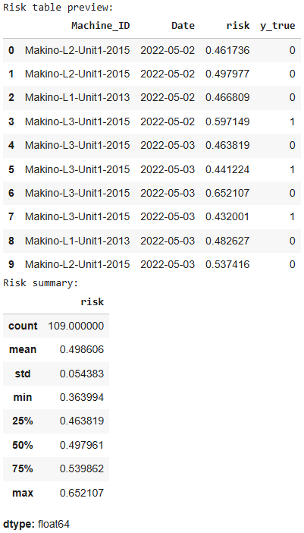

Figure 8. Risk Table Preview and Summary Statistics (Machine-Level Daily Risk Scores)

RQ3: Main drivers of the risk score and actionable explanations. RQ3 frames the model output as a risk score that must be explainable to build user trust and support maintenance decision-making. This follows XAI literature in predictive maintenance, which emphasizes combining global explanations (to understand overall model behavior) with local/instance-level explanations (to clarify why a specific case triggers an alert) (Cummins et al., 2024; Pashami et al., 2023).

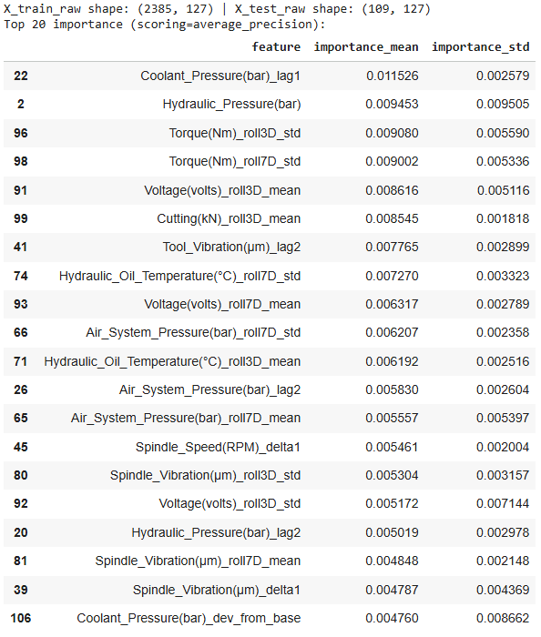

Figure 9. Permutation Importance (Scoring=Average Precision): Top Feature Drivers of the Risk Score

Figure 9 indicates that the largest contributions come from the coolant–hydraulic subsystem, torque-related metrics, electrical signals (voltage), cutting-process indicators, and vibration. This aligns with multi-sensor PdM practice in manufacturing, where combining process load signals (e.g., torque/cutting) and mechanical condition signals (e.g., vibration) often reveals early degradation or component wear (Ucar et al., 2024; Wang et al., 2024). Notably, many of the top features are lag/rolling/delta/rolling-std variables, suggesting the model is more sensitive to instability and changes over time than to raw sensor levels. This “instability-first” pattern is also reported in PdM studies showing that change-, trend-, and variability-based features can provide earlier warning signals before shutdown or failure occurs (Choi et al., 2022; Gama et al., 2024)

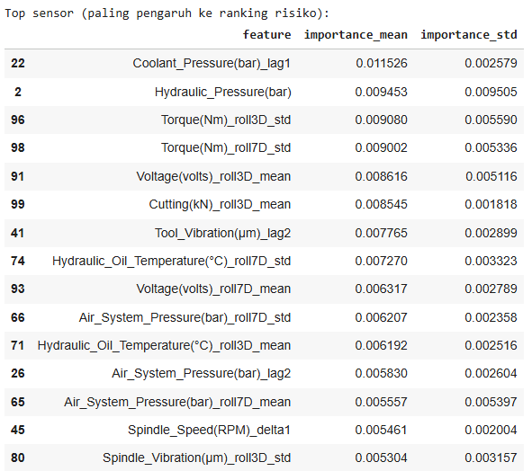

Figure 10. Top Sensor Drivers for Risk Ranking (Permutation Importance)

To strengthen the narrative, Figure 10 can aggregate the features into two categories, raw sensor levels versus instability features (e.g., rolling std, deltas, and lags), so readers can clearly see that pattern changes are the key signal captured by the model. After presenting this global view, the discussion can then narrow to what matters most for users in practice: the records that actually trigger alerts.

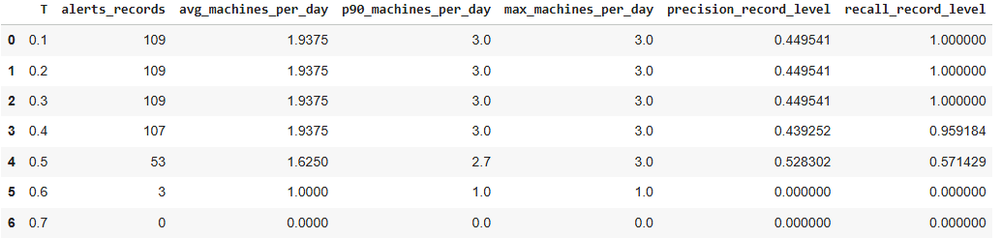

Figure 11. Threshold vs Alert Workload: Alerts per Day and Machines per Day (p90/Avg/Max)

Figure 11 shows that alerts are most often driven by Torque and Cutting features, followed by Spindle_Vibration and Tool_Vibration. Operationally, this supports grouping the main causes into two clusters: (1) cutting-load and process dynamics (e.g., tool wear, material load, process settings) and (2) rotating mechanical health (e.g., bearing condition, alignment, imbalance) reflected in vibration signals. This pattern matches prior studies emphasizing feature-based interpretation to connect alerts to specific components or processes (Gawde et al., 2024; Wang et al., 2024). The appearance of coolant/hydraulic/pressure and voltage drivers further suggests that supporting subsystems often act as disturbance enablers: when cooling, hydraulics/pneumatics, or electrical conditions degrade, process stability is affected and risk increases. This is consistent with PdM findings in hydraulic systems, where pressure/temperature/flow signals are commonly used as health indicators and root-cause clues (Yan et al., 2023). To make the interpretation truly actionable, these drivers should be translated into concrete maintenance actions.

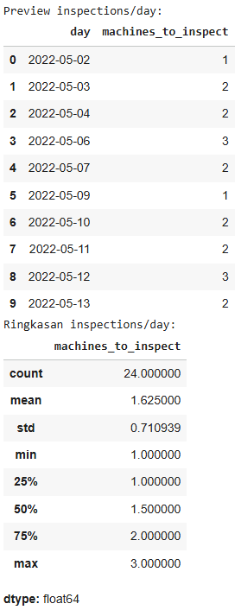

Figure 12. Daily Inspection Plan Preview and Summary (Machines to Inspect per Day)

Figure 12 (the driver-to-action/inspection-checklist mapping table) serves as a bridge from the model’s “reason” to concrete inspection steps. This aligns with interactive and human-in-the-loop XAI research for maintenance decision-making, which emphasizes turning explanations into practical guidance that technicians can directly apply (Amaliah et al., 2025; Rajaoarisoa et al., 2025).

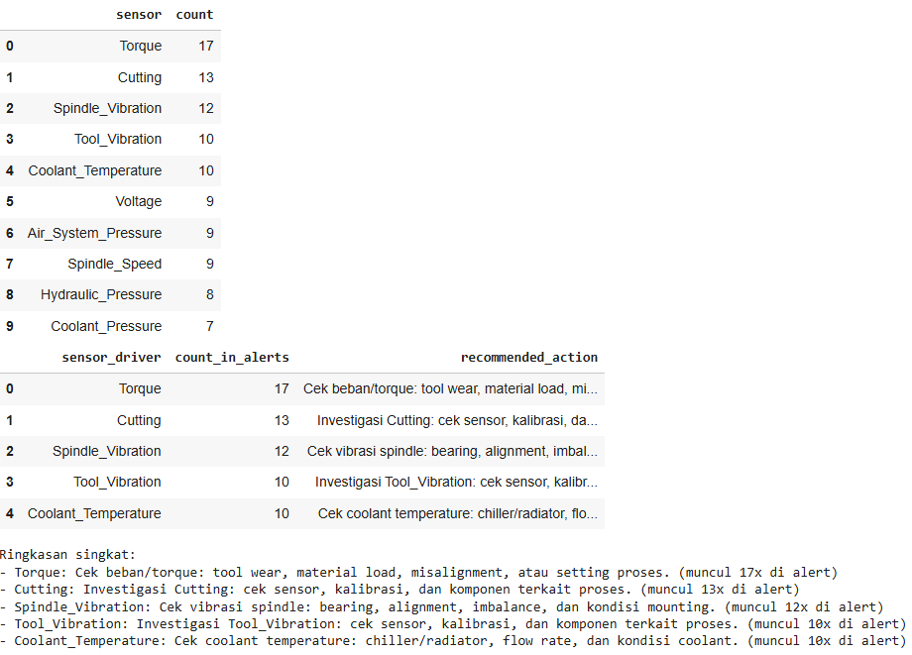

Figure 13. Alert Driver Frequency and Recommended Inspection Actions by Sensor

Finally, to build trust and demonstrate the full end-to-end workflow, include 1–2 high-risk case examples (Figure 13: a table of high-risk cases showing risk_score + top_drivers). This helps readers see the practical sequence: the system ranks a record as high risk → highlights the dominant drivers → the technician refers to the action checklist. This narrative approach aligns with modern PdM trends that combine alerts + explanations + root-cause cues, so the system is not perceived as a black box (Choi et al., 2022; Gama et al., 2024).

4. Conclution
This study develops an end-to-end predictive maintenance pipeline that produces a failure risk score from multi-sensor tabular data and supports proactive, transparent maintenance decisions through interpretability. Using a next-step failure (y_next) formulation with a time-based split to mirror real deployment, a three-model comparison identifies Random Forest as the strongest option for risk ranking (PR-AUC 0.462; precision 0.528; recall 0.571 at a 0.5 threshold), outperforming Logistic Regression and HistGradientBoosting. Key drivers from permutation importance concentrate in the torque–cutting–vibration cluster, with supporting subsystems (coolant, hydraulics, electrical), and these insights are translated into an inspection checklist so alerts provide not only a score but also clear reasons and recommended actions.
Operationally, the probability score functions as an alarm policy: threshold sweeping reveals a direct trade-off between minimizing missed failures (higher recall at lower thresholds) and controlling inspection burden (higher precision at higher thresholds), so threshold selection should be explicitly tied to maintenance capacity. The system can be deployed either as record-level ranking (alert on top scores or above a threshold) or as daily machine prioritization by aggregating scores per machine (e.g., max/p95/mean) into a top-N list. Key limitations include a small test set, a short prediction horizon, and limited contextual variables (e.g., maintenance history, tool changes, product/material type, operating conditions), motivating future work on probability calibration, richer contextual features, and stricter cross-machine/line generalization tests before production-scale deployment.

Daftar Pustaka
Amaliah, N. R., Tjahjono, B., & Palade, V. (2025). Human-in-the-Loop XAI for Predictive Maintenance: A Systematic Review of Interactive Systems and Their Effectiveness in Maintenance Decision-Making. In Electronics (Switzerland) (Vol. 14, Issue 17). Multidisciplinary Digital Publishing Institute (MDPI). https://doi.org/10.3390/electronics14173384
Ayvaz, S., & Alpay, K. (2021). Predictive maintenance system for production lines in manufacturing: A machine learning approach using IoT data in real-time. Expert Systems with Applications, 173. https://doi.org/10.1016/j.eswa.2021.114598
Benhanifia, A., Cheikh, Z. Ben, Oliveira, P. M., Valente, A., & Lima, J. (2025). Systematic review of predictive maintenance practices in the manufacturing sector. In Intelligent Systems with Applications (Vol. 26). https://doi.org/10.1016/j.iswa.2025.200501
Choi, H., Kim, D., Kim, J., Kim, J., & Kang, P. (2022). Explainable anomaly detection framework for predictive maintenance in manufacturing systems. Applied Soft Computing, 125. https://doi.org/10.1016/j.asoc.2022.109147
Cummins, L., Sommers, A., Ramezani, S. B., Mittal, S., Jabour, J., Seale, M., & Rahimi, S. (2024). Explainable Predictive Maintenance: A Survey of Current Methods, Challenges and Opportunities. http://arxiv.org/abs/2401.07871
Deng, A. (2023). Time series cross validation: A theoretical result and finite sample performance. Economics Letters, 233. https://doi.org/10.1016/j.econlet.2023.111369
Dereci, U., & Tuzkaya, G. (2024). An explainable artificial intelligence model for predictive maintenance and spare parts optimization. Supply Chain Analytics, 8. https://doi.org/10.1016/j.sca.2024.100078
Gama, J., Ribeiro, R. P., Mastelini, S., Davari, N., & Veloso, B. (2024). From fault detection to anomaly explanation: A case study on predictive maintenance. Journal of Web Semantics, 81. https://doi.org/10.1016/j.websem.2024.100821
Gawde, S., Patil, S., Kumar, S., Kamat, P., Kotecha, K., & Alfarhood, S. (2024). Explainable Predictive Maintenance of Rotating Machines Using LIME, SHAP, PDP, ICE. IEEE Access, 12. https://doi.org/10.1109/ACCESS.2024.3367110
Huberts, L. C. E., Does, R. J. M. M., Ravesteijn, B., & Lokkerbol, J. (2022). Predictive monitoring using machine learning algorithms and a real-life example on schizophrenia. Quality and Reliability Engineering International, 38(3). https://doi.org/10.1002/qre.2957
Kapoor, S., & Narayanan, A. (2023). Leakage and the reproducibility crisis in machine-learning-based science. Patterns, 4(9). https://doi.org/10.1016/j.patter.2023.100804
Levin, S. (2024). Enhancing Predictive Maintenance in the Industrial Sector: A Comparative Analysis of Machine Learning Models. AIP Conference Proceedings, 3243(1). https://doi.org/10.1063/5.0247617
Li, Z., He, Q., & Li, J. (2024). A survey of deep learning-driven architecture for predictive maintenance. In Engineering Applications of Artificial Intelligence (Vol. 133). https://doi.org/10.1016/j.engappai.2024.108285
Liebman, E. (2024). Pattern-Based Time-Series Risk Scoring for Anomaly Detection and Alert Filtering -- A Predictive Maintenance Case Study. Journal of Computer Science.
Luo, Y., Gopaluni, B., Cao, L., Wang, Y., & Cheng, J. (2023). Adaptive online optimization of alarm thresholds using multilayer Bayesian networks and active transfer entropy. Control Engineering Practice, 137. https://doi.org/10.1016/j.conengprac.2023.105534
Mahale, Y., Kolhar, S., & More, A. S. (2025). Enhancing predictive maintenance in automotive industry: addressing class imbalance using advanced machine learning techniques. Discover Applied Sciences, 7(4). https://doi.org/10.1007/s42452-025-06827-3
Manca, G., & Fay, A. (2024). Convolutional kernel-based classification of industrial alarm floods. Data-Centric Engineering, 5. https://doi.org/10.1017/dce.2024.22
McDermott, M. B., Zhang, H., Hansen, L. H., Angelotti, G., & Gallifant, J. (2024). A Closer Look at AUROC and AUPRC under Class Imbalance. Advances in Neural Information Processing Systems, 37. https://doi.org/10.52202/079017-1400
Mustafa, F. E., Ahmed, I., Basit, A., Alvi, U. E. H., Malik, S. H., Mahmood, A., & Ali, P. R. (2023). A review on effective alarm management systems for industrial process control: Barriers and opportunities. In International Journal of Critical Infrastructure Protection (Vol. 41). https://doi.org/10.1016/j.ijcip.2023.100599
Pashami, S., Nowaczyk, S., Fan, Y., Jakubowski, J., Paiva, N., Davari, N., Bobek, S., Jamshidi, S., Sarmadi, H., Alabdallah, A., Ribeiro, R. P., Veloso, B., Sayed-Mouchaweh, M., Rajaoarisoa, L., Nalepa, G. J., & Gama, J. (2023). Explainable Predictive Maintenance. http://arxiv.org/abs/2306.05120
Rajaoarisoa, L., Randrianandraina, R., Nalepa, G. J., & Gama, J. (2025). Decision-making systems improvement based on explainable artificial intelligence approaches for predictive maintenance. Engineering Applications of Artificial Intelligence, 139. https://doi.org/10.1016/j.engappai.2024.109601
Richardson, E., Trevizani, R., Greenbaum, J. A., Carter, H., Nielsen, M., & Peters, B. (2024). The receiver operating characteristic curve accurately assesses imbalanced datasets. Patterns, 5(6). https://doi.org/10.1016/j.patter.2024.100994
Serradilla, O., Zugasti, E., Rodriguez, J., & Zurutuza, U. (2022). Deep learning models for predictive maintenance: a survey, comparison, challenges and prospects. Applied Intelligence, 52(10). https://doi.org/10.1007/s10489-021-03004-y
Shadi, M. R., Mirshekali, H., & Shaker, H. R. (2025). Explainable artificial intelligence for energy systems maintenance: A review on concepts, current techniques, challenges, and prospects. In Renewable and Sustainable Energy Reviews (Vol. 216). https://doi.org/10.1016/j.rser.2025.115668
Steurtewagen, B., & Van den Poel, D. (2021). Adding interpretability to predictive maintenance by machine learning on sensor data. Computers and Chemical Engineering, 152. https://doi.org/10.1016/j.compchemeng.2021.107381
Tsallis, C., Papageorgas, P., Piromalis, D., & Munteanu, R. A. (2025). Application-Wise Review of Machine Learning-Based Predictive Maintenance: Trends, Challenges, and Future Directions. In Applied Sciences (Switzerland) (Vol. 15, Issue 9). https://doi.org/10.3390/app15094898
Ucar, A., Karakose, M., & Kırımça, N. (2024). Artificial Intelligence for Predictive Maintenance Applications: Key Components, Trustworthiness, and Future Trends. In Applied Sciences (Switzerland) (Vol. 14, Issue 2). https://doi.org/10.3390/app14020898
von Stackelberg, P., Goedhart, R., Birbil, İ., & Does, R. J. M. M. (2024). Comparison of threshold tuning methods for predictive monitoring. Quality and Reliability Engineering International, 40(1). https://doi.org/10.1002/qre.3436
Wang, K., Wang, A., Wu, L., & Xie, G. (2024). Machine Tool Wear Prediction Technology Based on Multi-Sensor Information Fusion. Sensors, 24(8). https://doi.org/10.3390/s24082652
Wu, M., Goh, K. W., Chaw, K. H., Koh, Y. S., Dares, M., Yeong, C. F., Su, E. L. M., William, H., & Zhang, Y. (2024). An intelligent predictive maintenance system based on random forest for addressing industrial conveyor belt challenges. Frontiers in Mechanical Engineering, 10. https://doi.org/10.3389/fmech.2024.1383202
Yadav, D. K., Kaushik, A., & Yadav, N. (2024). Predicting machine failures using machine learning and deep learning algorithms. Sustainable Manufacturing and Service Economics, 3. https://doi.org/10.1016/j.smse.2024.100029
Yan, W., Shi, Y., Ji, Z., Sui, Y., Tian, Z., Wang, W., & Cao, Q. (2023). Intelligent predictive maintenance of hydraulic systems based on virtual knowledge graph. Engineering Applications of Artificial Intelligence, 126. https://doi.org/10.1016/j.engappai.2023.106798
Yang, Y., & Wang, H. (2025). Random Forest-Based Machine Failure Prediction: A Performance Comparison. Applied Sciences (Switzerland), 15(16). https://doi.org/10.3390/app15168841

